**Comprehensive System Evaluation and Performance Analysis**

1. **Chapter Structure**
2. Introduction to Evaluation and Novelty
3. Experimental Setup
4. Results Under Different BS Mobility Modes

3.1 Fixed BS

3.2 Circular BS

3.3 Random BS

1. Discussion & Summary of Key Findings
2. All RLHC simulation available here: link : <https://tinyurl.com/2y9y85tb>
3. **Introduction to Evaluation and Novelty**

This chapter presents a comprehensive evaluation of the proposed RL‑based hybrid clustering and multi‑hop routing protocol for wireless sensor networks. The goal is to quantify how each component of the architecture contributes to network performance and to demonstrate that the integration of reinforcement learning with multi‑layer clustering and routing is both effective and novel.

We evaluate the system under three different base station (BS) mobility patterns: fixed, circular and random. For each mobility mode, we conduct a systematic layer enable/disable study, where we compare the full 5‑layers (DEEC + EEKA + K‑means + RL + Multi‑Hop) against individual layers turned off. The proposed approach is benchmark against multiple optimization algorithms, including Fuzzy C-Means (FCM), Particle Swarm Optimization–Genetic Algorithm (PSO-GA), Ant Colony Optimization (ACO), as well as two well-known baseline protocols: Distributed Energy-Efficient Clustering (DEEC) and Low Energy Adaptive Clustering Hierarchy (LEACH).

Performance is analyzed using a rich set of metrics:

1. Lifetime and Reliability metrics:
   1. FND(1st node death), (50% node death), (75% node death) LND(last node death) & PDR
   2. Dead nodes vs Rounds
2. Data delivery and Energy metrics:
   1. Throughput vs Rounds
   2. Energy consumption vs Rounds
3. Spatial behavior:
   1. Sector‑wise coverage vs Rounds

This evaluation design serves two purposes:

1. Justifying novelty of the architecture: By varying BS mobility and selectively enabling or disabling layers, we show that the protocol behaves as a self‑optimizing system, where the RL layer acts as a global control plane on top of hybrid clustering and multi‑hop routing.
2. Quantifying the specific impact of RL and hybrid clustering: Comparing Full vs No‑RL configurations across all BS mobility modes highlights how RL improves adaptation to network state and BS movement.
3. **Experimental Setup**

AREA_SIZE = 1000 # meters L, B

N_NODES = 150 # number of sensor nodes

INIT_ENERGY = 2.0 # joules per node

NUM_CLUSTERS = int(N_NODES * 0.1)

ROUNDS = 1000

PACKET_SIZE_BYTES = 128

PACKET_SIZE_BITS = PACKET_SIZE_BYTES * 8

N_HALF = N_NODES // 2

SECTOR_ROWS = 3

SECTOR_COLS = 3

First‑order radio model : AWGN channel

1. **Results Under Different BS Mobility Modes**

This section presents the performance of the proposed RL‑based hybrid clustering protocol under three base station (BS) mobility modes: fixed, circular and random.

***3.1 Fixed BS***

In the fixed BS scenario, the base station remains at a constant position throughout the 1000 rounds of simulation. This represents a conventional WSN deployment and serves as a baseline to understand how much improvement is obtained before introducing BS mobility.

|  |  |  |  |  |  |
| --- | --- | --- | --- | --- | --- |
| **CONFIG: RLHC** | **Layer 1: ✅** | **Layer 2: ✅** | **Layer 3: ✅** | **Layer 4: ✅** | **Layer 5: ✅** |

|  |  |  |  |  |  |
| --- | --- | --- | --- | --- | --- |
| **Method** | **1st Node Death (rounds)** | **50% Nodes Death (rounds)** | **75% Nodes Death (round)** | **100% Node Death (round)** | **%PDR** |
| LEACH | 19 | 42 | 4683 | 5591 | 99.74 |
| DEEC | 13 | 153 | 7890 | 8093 | 99.77 |
| FCM | 15 | 464 | 15045 | 18090 | 99.52 |
| PSO-GA | 26 | 487 | 12054 | 14311 | 99.72 |
| ACO | 24 | 458 | 10003 | 12886 | 99.86 |
| RLHC (proposed) | 225 | 1111 | 17890 | 21057 | 99.99 |

**Table 1:** Lifetime vs Rounds

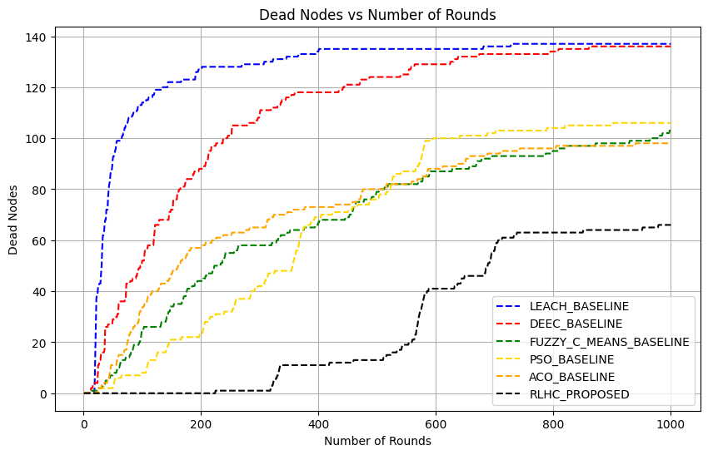

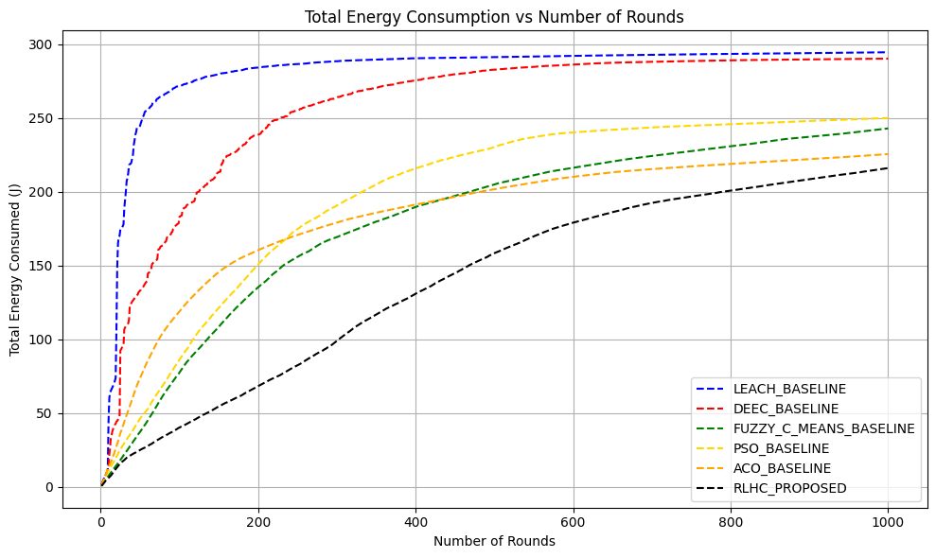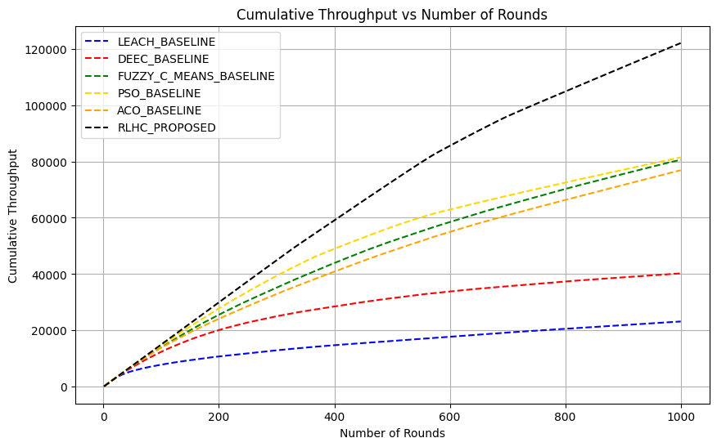**Table 2:** Energy consumed and Throughput vs Rounds

|  |  |  |
| --- | --- | --- |
| **Methods** | **Energy Consumed (J)** | **Throughput (kbps)** |
| LEACH | 294.5 | 23 |
| DEEC | 290.2 | 40 |
| FCM | 242.9 | 80 |
| PSO-GA | 250.0 | 81 |
| ACO | 225.5 | 76 |
| RLHC (proposed) | 216.0 | 120 |

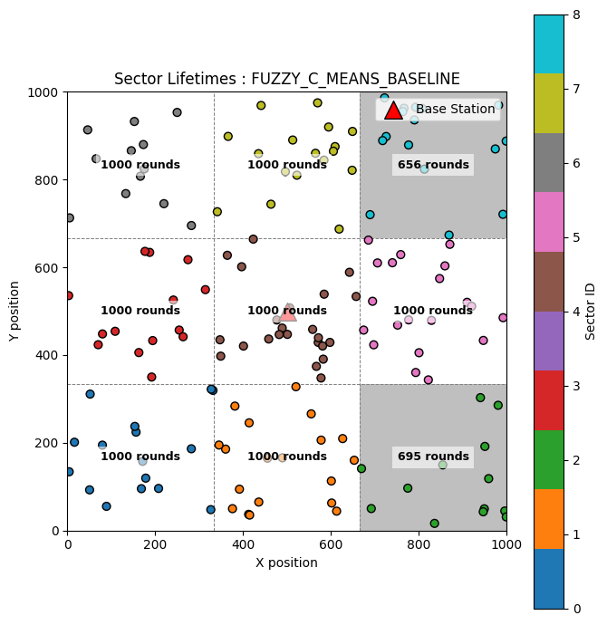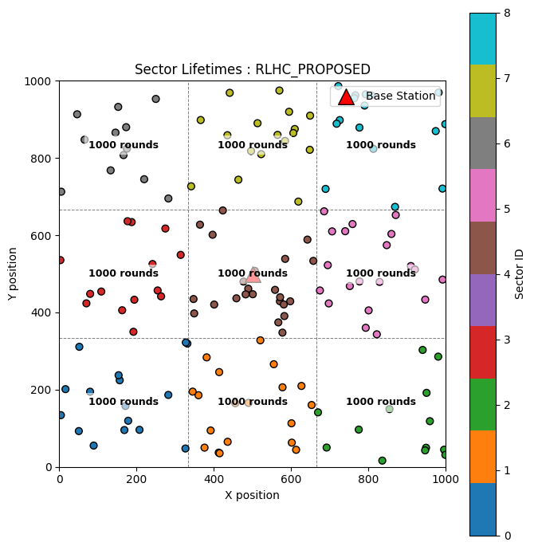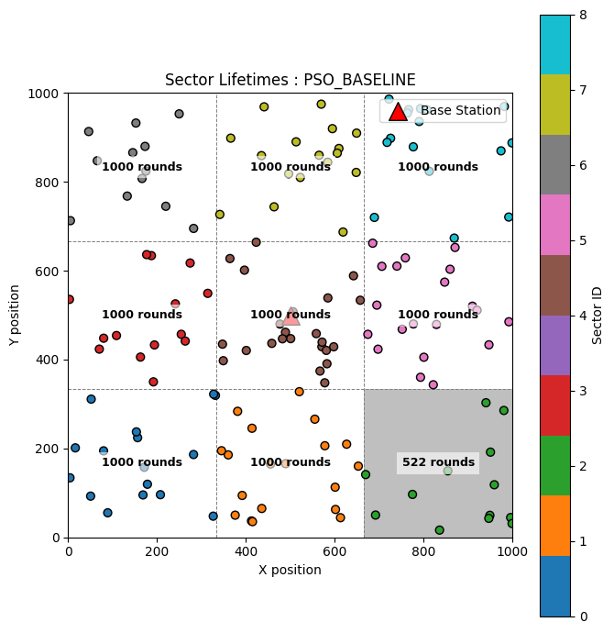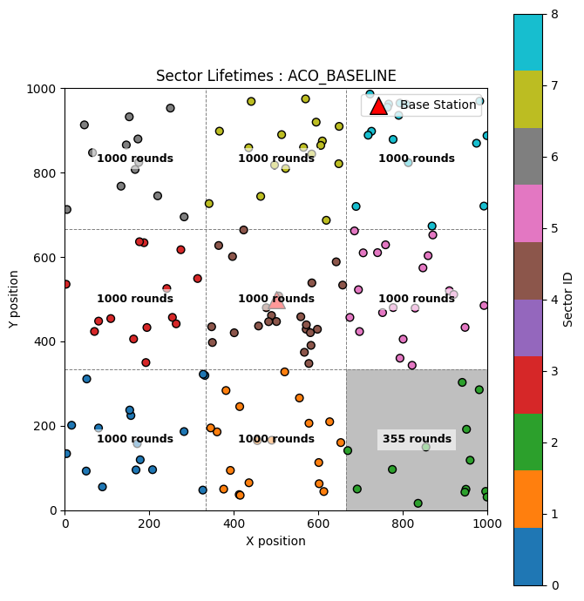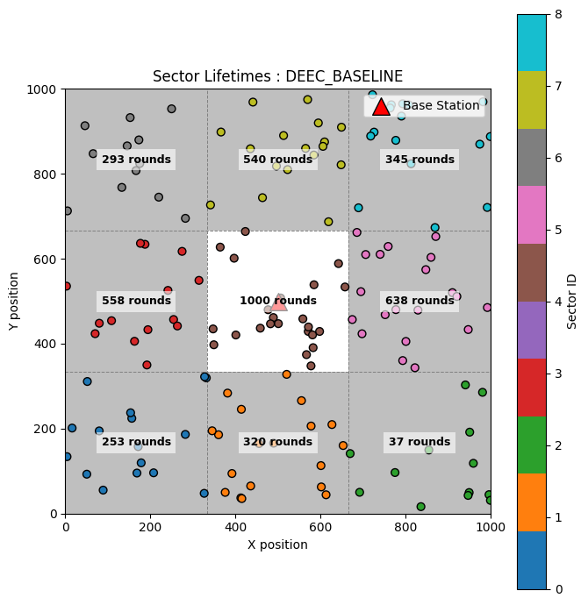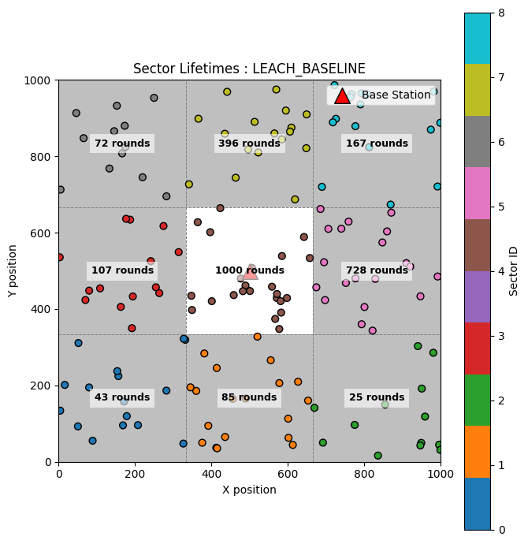

***Note: We now disable each layer individually and observe the impact it produces.***

|  |  |  |  |  |  |
| --- | --- | --- | --- | --- | --- |
| **CONFIG: RLHC** | **Layer 1: ✅** | **Layer 2: ✅** | **Layer 3: ✅** | **Layer 4: ✅** | **Layer 5:** ❌ |

**Table 1:** Lifetime vs Rounds

|  |  |  |  |  |  |
| --- | --- | --- | --- | --- | --- |
| **Method** | **1st Node Death (rounds)** | **50% Nodes Death (rounds)** | **75% Nodes Death (round)** | **100% Node Death (round)** | **%PDR** |
| LEACH | 19 | 42 | 4683 | 5591 | 99.74 |
| DEEC | 13 | 153 | 7890 | 8093 | 99.77 |
| FCM | 15 | 464 | 15045 | 18090 | 99.52 |
| PSO-GA | 26 | 487 | 12054 | 14311 | 99.72 |
| ACO | 24 | 458 | 10003 | 12886 | 99.86 |
| RLHC (proposed) | 137 | 1120 | 16243 | 18228 | 99.89 |

**Table 2:** Energy consumed and Throughput vs Rounds

|  |  |  |
| --- | --- | --- |
| **Methods** | **Energy Consumed (J)** | **Throughput (kbps)** |
| LEACH | 294.5 | 23 |
| DEEC | 290.2 | 40 |
| FCM | 242.9 | 80 |
| PSO-GA | 250.0 | 81 |
| ACO | 225.5 | 76 |
| RLHC (proposed) | 218.0 | 115 |



|  |  |  |  |  |  |
| --- | --- | --- | --- | --- | --- |
| **CONFIG: RLHC** | **Layer 1: ✅** | **Layer 2: ✅** | **Layer 3: ✅** | **Layer 4:** ❌ | **Layer 5:** ❌ |

**Table 1:** Lifetime vs Rounds

|  |  |  |  |  |  |
| --- | --- | --- | --- | --- | --- |
| **Method** | **1st Node Death (rounds)** | **50% Nodes Death (rounds)** | **75% Nodes Death (round)** | **100% Node Death (round)** | **%PDR** |
| LEACH | 19 | 42 | 4683 | 5591 | 99.74 |
| DEEC | 13 | 153 | 7890 | 8093 | 99.77 |
| FCM | 15 | 464 | 15045 | 18090 | 99.52 |
| PSO-GA | 26 | 487 | 12054 | 14311 | 99.72 |
| ACO | 24 | 458 | 10003 | 12886 | 99.86 |
| RLHC (proposed) | 97 | 681 | 9023 | 10013 | 99.75 |

**Table 2:** Energy consumed and Throughput vs Rounds

|  |  |  |
| --- | --- | --- |
| **Methods** | **Energy Consumed (J)** | **Throughput (kbps)** |
| LEACH | 294.5 | 23 |
| DEEC | 290.2 | 40 |
| FCM | 242.9 | 80 |
| PSO-GA | 250.0 | 81 |
| ACO | 225.5 | 76 |
| RLHC (proposed) | 244.0 | 93 |

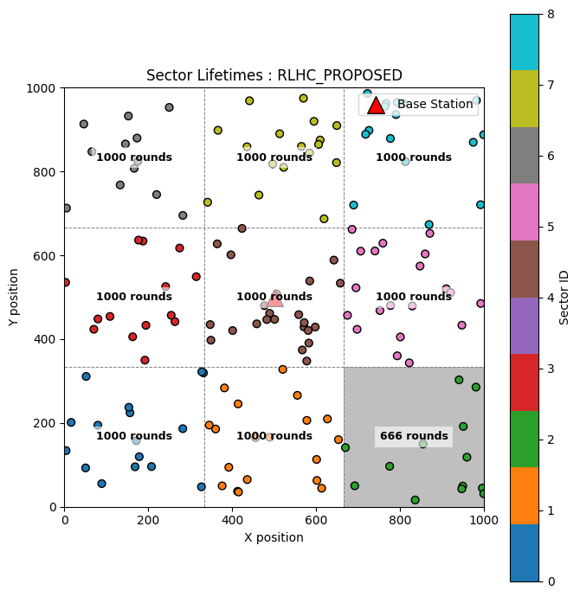

|  |  |  |  |  |  |
| --- | --- | --- | --- | --- | --- |
| **CONFIG: RLHC** | **Layer 1: ✅** | **Layer 2: ✅** | **Layer 3:** ❌ | **Layer 4:** ❌ | **Layer 5:** ❌ |

**Table 1:** Lifetime vs Rounds

|  |  |  |  |  |  |
| --- | --- | --- | --- | --- | --- |
| **Method** | **1st Node Death (rounds)** | **50% Nodes Death (rounds)** | **75% Nodes Death (round)** | **100% Node Death (round)** | **%PDR** |
| LEACH | 19 | 42 | 4683 | 5591 | 99.74 |
| DEEC | 13 | 153 | 7890 | 8093 | 99.77 |
| FCM | 15 | 464 | 15045 | 18090 | 99.52 |
| PSO-GA | 26 | 487 | 12054 | 14311 | 99.72 |
| ACO | 24 | 458 | 10003 | 12886 | 99.86 |
| RLHC (proposed) | 48 | 601 | 7023 | 8201 | 99.89 |

**Table 2:** Energy consumed and Throughput vs Rounds

|  |  |  |
| --- | --- | --- |
| **Methods** | **Energy Consumed (J)** | **Throughput (kbps)** |
| LEACH | 294.5 | 23 |
| DEEC | 290.2 | 40 |
| FCM | 242.9 | 80 |
| PSO-GA | 250.0 | 81 |
| ACO | 225.5 | 76 |
| RLHC (proposed) | 241.0 | 91 |

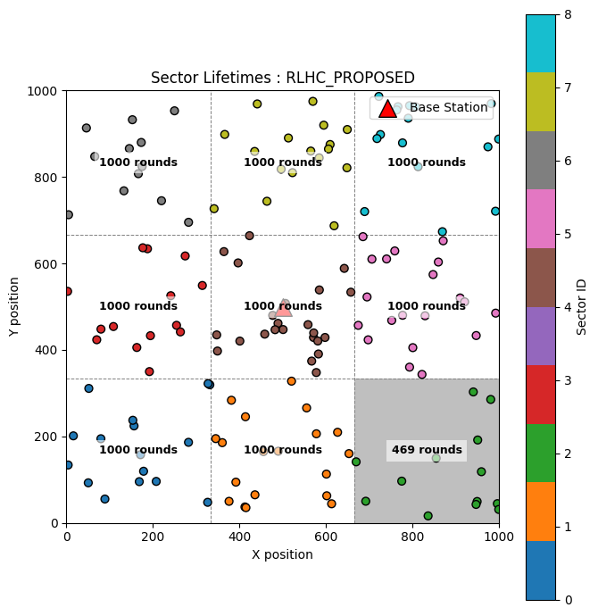

|  |  |  |  |  |  |
| --- | --- | --- | --- | --- | --- |
| **CONFIG: RLHC** | **Layer 1: ✅** | **Layer 2:** ❌ | **Layer 3:** ❌ | **Layer 4:** ❌ | **Layer 5:** ❌ |

**Table 1:** Lifetime vs Rounds

|  |  |  |  |  |  |
| --- | --- | --- | --- | --- | --- |
| **Method** | **1st Node Death (rounds)** | **50% Nodes Death (rounds)** | **75% Nodes Death (round)** | **100% Node Death (round)** | **%PDR** |
| LEACH | 19 | 42 | 4683 | 5591 | 99.74 |
| DEEC | 13 | 153 | 7890 | 8093 | 99.77 |
| FCM | 15 | 464 | 15045 | 18090 | 99.52 |
| PSO-GA | 26 | 487 | 12054 | 14311 | 99.72 |
| ACO | 24 | 458 | 10003 | 12886 | 99.86 |
| RLHC (proposed) | 52 | 472 | 6023 | 7111 | 99.83 |

**Table 2:** Energy consumed and Throughput vs Rounds

|  |  |  |
| --- | --- | --- |
| **Methods** | **Energy Consumed (J)** | **Throughput (kbps)** |
| LEACH | 294.5 | 23 |
| DEEC | 290.2 | 40 |
| FCM | 242.9 | 80 |
| PSO-GA | 250.0 | 81 |
| ACO | 225.5 | 76 |
| RLHC (proposed) | 250.0 | 80 |

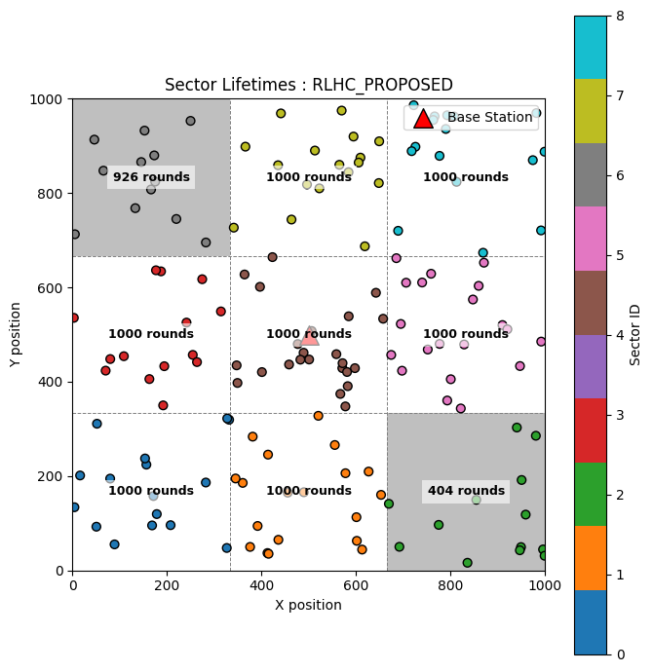

***3.2* Circular BS**

In the circular BS scenario, the base station moves at a constant speed along a circular path centered in the sensing field for 500 simulation rounds, with a radius of 300 meters. The BS completes one full revolution in 275 rounds, which corresponds to an angular velocity of ω=2π/275 radians per round and a linear velocity of 6.85 m/sec.

|  |  |  |  |  |  |
| --- | --- | --- | --- | --- | --- |
| **CONFIG: RLHC** | **Layer 1: ✅** | **Layer 2: ✅** | **Layer 3: ✅** | **Layer 4: ✅** | **Layer 5: ✅** |

**Table 3:** Lifetime vs Rounds

|  |  |  |  |  |  |
| --- | --- | --- | --- | --- | --- |
| **Method** | **1st Node Death (rounds)** | **50% Nodes Death (rounds)** | **75% Nodes Death (round)** | **100% Node Death (round)** | **%PDR** |
| LEACH | 10 | 42 | 550 | 706 | 98.55 |
| DEEC | 35 | 166 | 723 | 945 | 99.57 |
| FCM | 7 | 150 | 650 | 1092 | 97.88 |
| PSO-GA | 6 | 187 | 721 | 837 | 98.64 |
| ACO | 19 | 195 | 403 | 587 | 98.40 |
| RLHC (proposed) | 122 | 575 | 936 | 1568 | 99.98 |

**Table 2:** Energy consumed and Throughput vs Rounds

|  |  |  |
| --- | --- | --- |
| **Methods** | **Energy Consumed (J)** | **Throughput (kbps)** |
| LEACH | 296.7 | 15 |
| DEEC | 288.7 | 32 |
| FCM | 279.9 | 28 |
| PSO-GA | 283.1 | 34 |
| ACO | 297.3 | 31 |
| RLHC (proposed) | 264.7 | 71 |

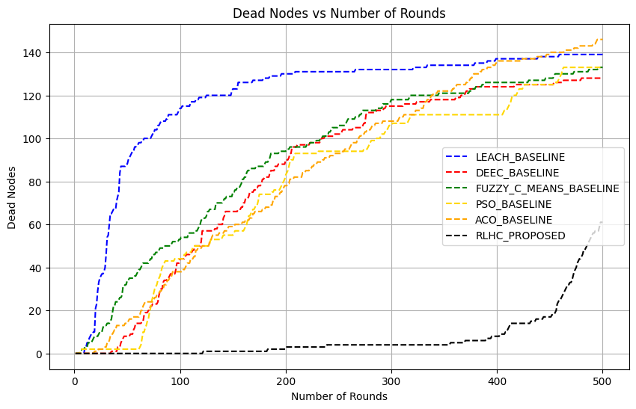

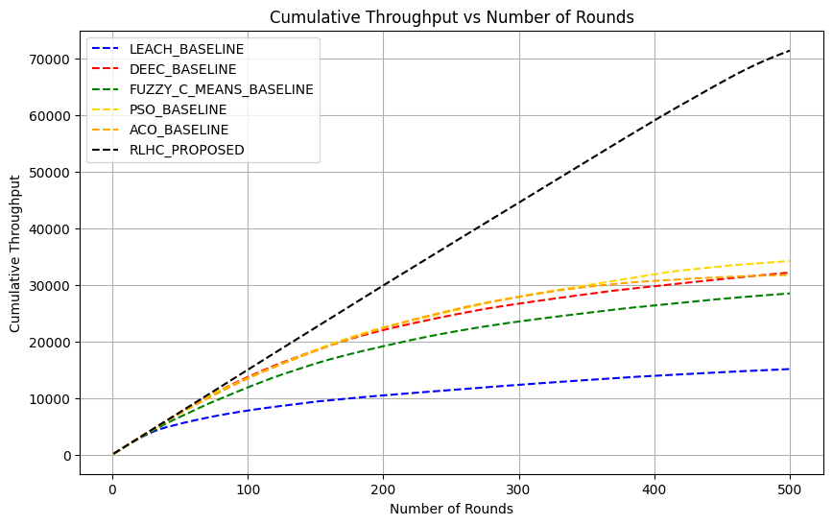

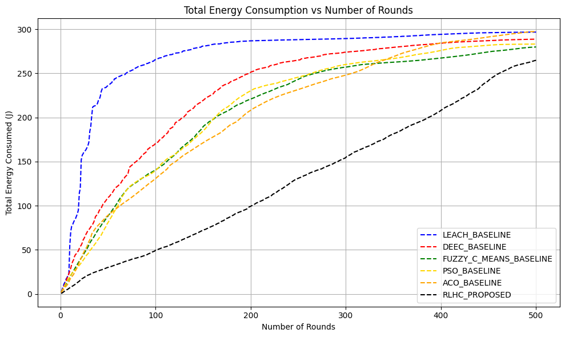

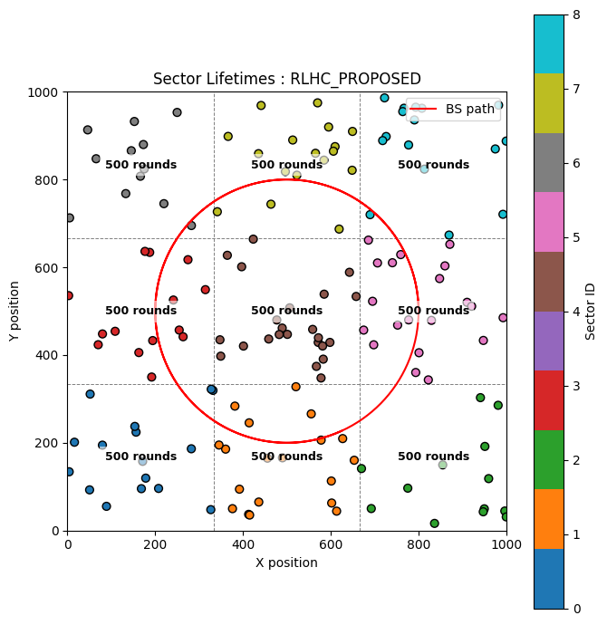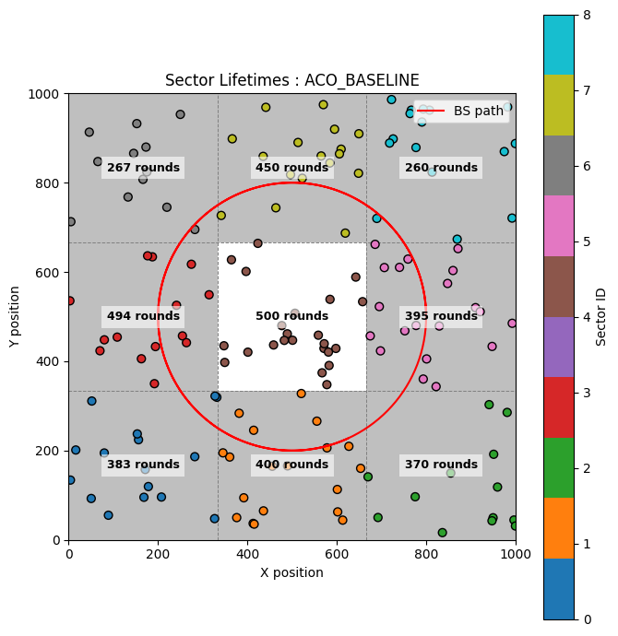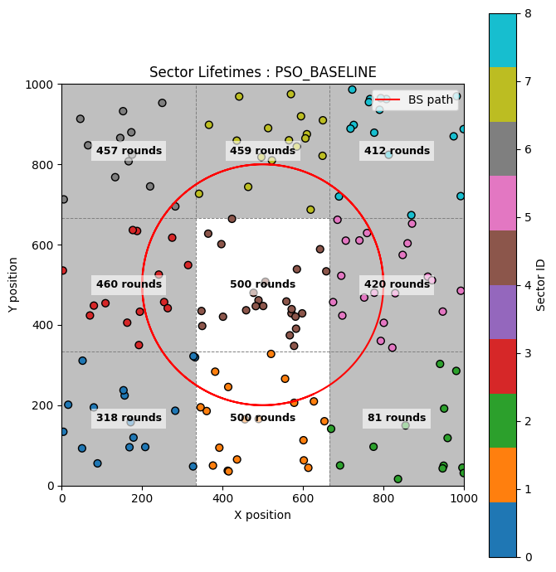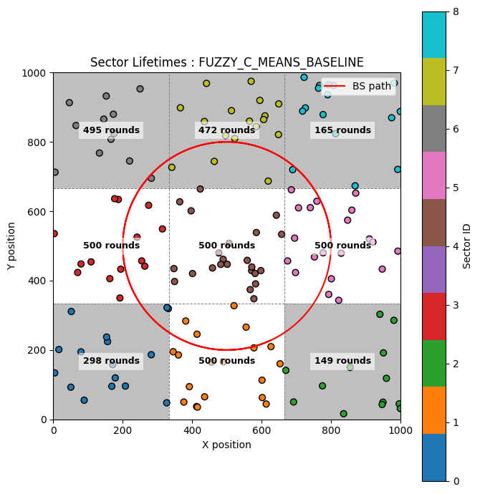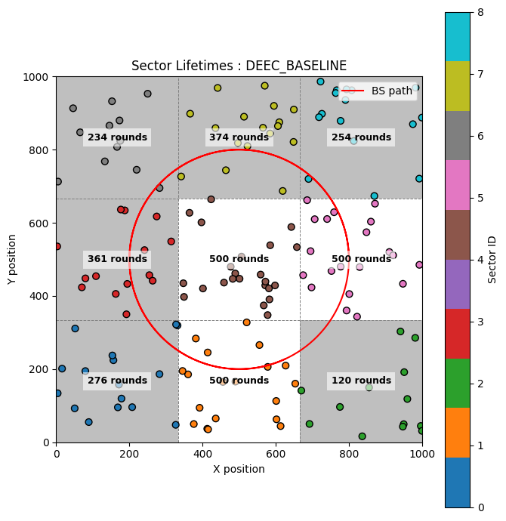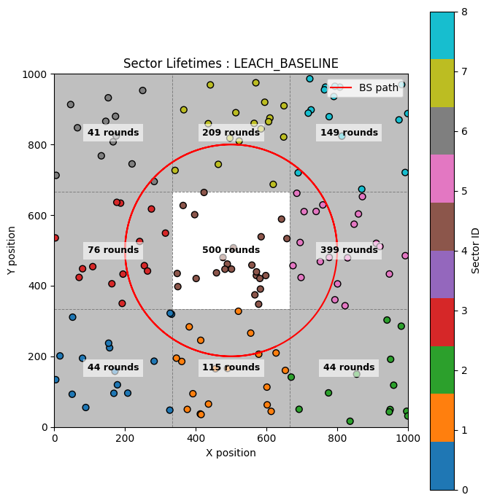

***Note: We now disable each layer individually and observe the impact it produces.***

|  |  |  |  |  |  |
| --- | --- | --- | --- | --- | --- |
| **CONFIG: RLHC** | **Layer 1: ✅** | **Layer 2: ✅** | **Layer 3: ✅** | **Layer 4: ✅** | **Layer 5:** ❌ |

**Table 1:** Lifetime vs Rounds

|  |  |  |  |  |  |
| --- | --- | --- | --- | --- | --- |
| **Method** | **1st Node Death (rounds)** | **50% Nodes Death (rounds)** | **75% Nodes Death (round)** | **100% Node Death (round)** | **%PDR** |
| LEACH | 10 | 42 | 550 | 706 | 98.55 |
| DEEC | 35 | 166 | 723 | 945 | 99.57 |
| FCM | 7 | 150 | 650 | 1092 | 97.88 |
| PSO-GA | 6 | 187 | 721 | 837 | 98.64 |
| ACO | 19 | 195 | 403 | 587 | 98.40 |
| RLHC (proposed) | 25 | 319 | 835 | 962 | 99.81 |

**Table 2:** Energy consumed and Throughput vs Rounds

|  |  |  |
| --- | --- | --- |
| **Methods** | **Energy Consumed (J)** | **Throughput (kbps)** |
| LEACH | 296.7 | 15 |
| DEEC | 288.7 | 32 |
| FCM | 279.9 | 28 |
| PSO-GA | 283.1 | 34 |
| ACO | 297.3 | 31 |
| RLHC (proposed) | 268.5 | 46 |

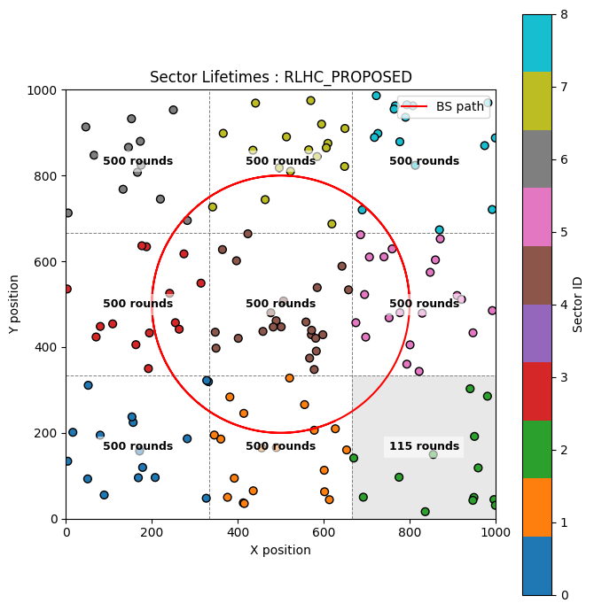

|  |  |  |  |  |  |
| --- | --- | --- | --- | --- | --- |
| **CONFIG: RLHC** | **Layer 1: ✅** | **Layer 2: ✅** | **Layer 3: ✅** | **Layer 4:** ❌ | **Layer 5:** ❌ |

**Table 1:** Lifetime vs Rounds

|  |  |  |  |  |  |
| --- | --- | --- | --- | --- | --- |
| **Method** | **1st Node Death (rounds)** | **50% Nodes Death (rounds)** | **75% Nodes Death (round)** | **100% Node Death (round)** | **%PDR** |
| LEACH | 10 | 42 | 550 | 706 | 98.55 |
| DEEC | 35 | 166 | 723 | 945 | 99.57 |
| FCM | 7 | 150 | 650 | 1092 | 97.88 |
| PSO-GA | 6 | 187 | 721 | 837 | 98.64 |
| ACO | 19 | 195 | 403 | 587 | 98.40 |
| RLHC (proposed) | 16 | 201 | 557 | 703 | 98.52 |

**Table 2:** Energy consumed and Throughput vs Rounds

|  |  |  |
| --- | --- | --- |
| **Methods** | **Energy Consumed (J)** | **Throughput (kbps)** |
| LEACH | 296.7 | 15 |
| DEEC | 288.7 | 32 |
| FCM | 279.9 | 28 |
| PSO-GA | 283.1 | 34 |
| ACO | 297.3 | 31 |
| RLHC (proposed) | 287.6 | 34 |

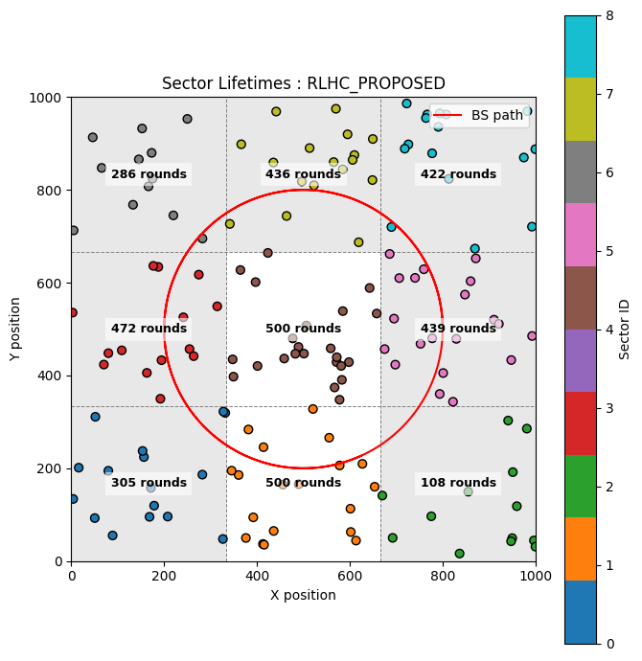

|  |  |  |  |  |  |
| --- | --- | --- | --- | --- | --- |
| **CONFIG: RLHC** | **Layer 1: ✅** | **Layer 2: ✅** | **Layer 3:** ❌ | **Layer 4:** ❌ | **Layer 5:** ❌ |

**Table 1:** Lifetime vs Rounds

|  |  |  |  |  |  |
| --- | --- | --- | --- | --- | --- |
| **Method** | **1st Node Death (rounds)** | **50% Nodes Death (rounds)** | **75% Nodes Death (round)** | **100% Node Death (round)** | **%PDR** |
| LEACH | 10 | 42 | 550 | 706 | 98.55 |
| DEEC | 35 | 166 | 723 | 945 | 99.57 |
| FCM | 7 | 150 | 650 | 1092 | 97.88 |
| PSO-GA | 6 | 187 | 721 | 837 | 98.64 |
| ACO | 19 | 195 | 403 | 587 | 98.40 |
| RLHC (proposed) | 16 | 201 | 281 | 475 | 97.52 |

**Table 2:** Energy consumed and Throughput vs Rounds

|  |  |  |
| --- | --- | --- |
| **Methods** | **Energy Consumed (J)** | **Throughput (kbps)** |
| LEACH | 296.7 | 15 |
| DEEC | 288.7 | 32 |
| FCM | 279.9 | 28 |
| PSO-GA | 283.1 | 34 |
| ACO | 297.3 | 31 |
| RLHC (proposed) | 299.9 | 14 |

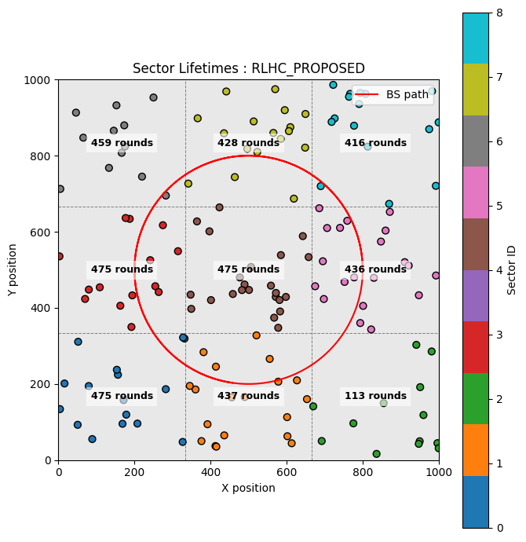

***3.3 Random* BS**

In the random BS scenario, the base station move at random location at each round, while ensuring it remains inside the sensing field. This random movement is applied for 150 simulation rounds.

|  |  |  |  |  |  |
| --- | --- | --- | --- | --- | --- |
| **CONFIG: RLHC** | **Layer 1: ✅** | **Layer 2: ✅** | **Layer 3: ✅** | **Layer 4: ✅** | **Layer 5: ✅** |

**Table 3:** Lifetime vs Rounds

|  |  |  |  |  |  |
| --- | --- | --- | --- | --- | --- |
| **Method** | **1st Node Death (rounds)** | **50% Nodes Death (rounds)** | **75% Nodes Death (round)** | **100% Node Death (round)** | **%PDR** |
| LEACH | 7 | 33 | 207 | 244 | 92.45 |
| DEEC | 13 | 93 | 205 | 241 | 98.08 |
| FCM | 7 | 61 | 554 | 598 | 93.42 |
| PSO-GA | 1 | 77 | 199 | 262 | 96.74 |
| ACO | 8 | 96 | 157 | 169 | 93.05 |
| RLHC (proposed) | 7 | 358 | 620 | 654 | 98.93 |

**Table 2:** Energy consumed and Throughput vs Rounds

|  |  |  |
| --- | --- | --- |
| **Methods** | **Energy Consumed (J)** | **Throughput (kbps)** |
| LEACH | 291.94 | 7 |
| DEEC | 284.12 | 14 |
| FCM | 277.73 | 10 |
| PSO-GA | 282.32 | 13 |
| ACO | 296.28 | 13 |
| RLHC (proposed) | 129.84 | 21 |

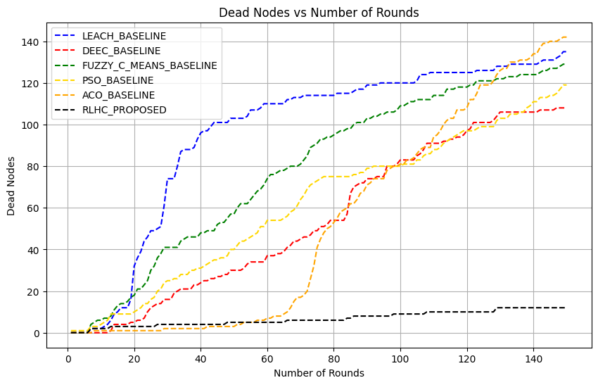

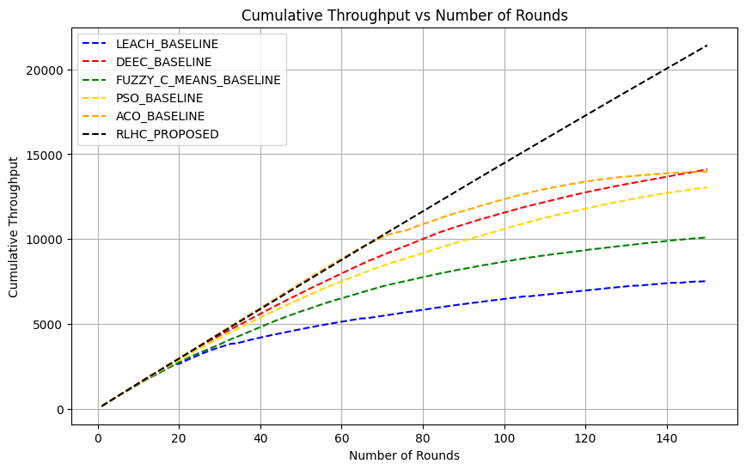

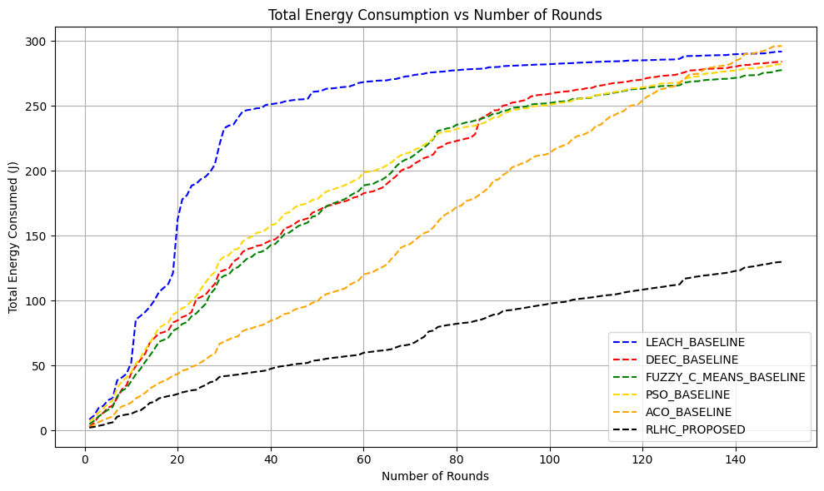

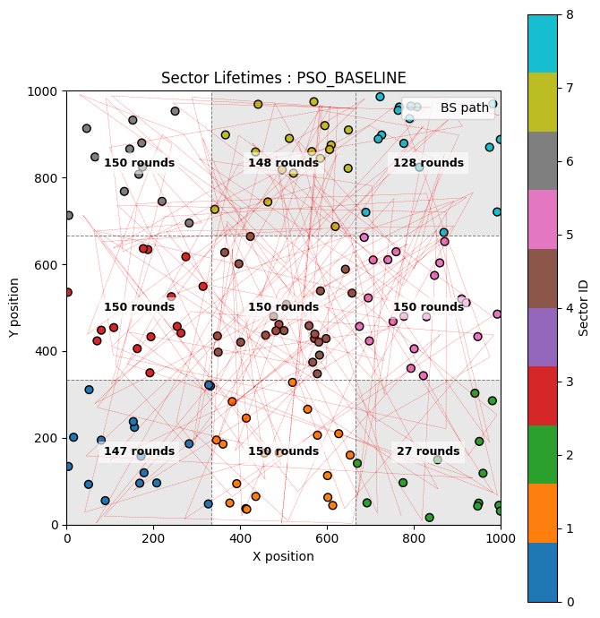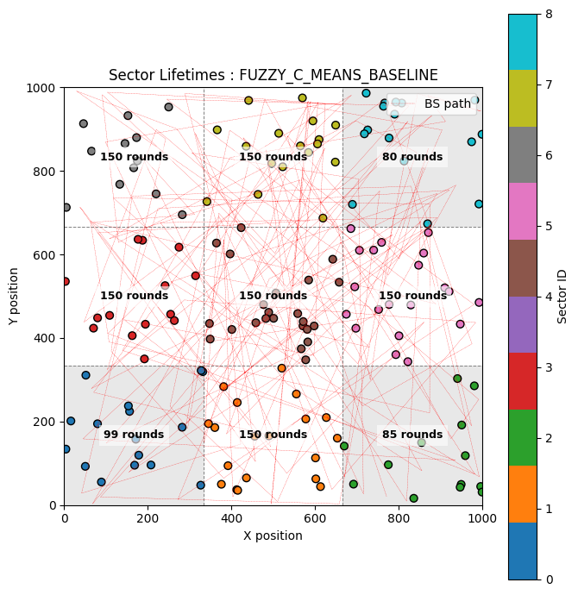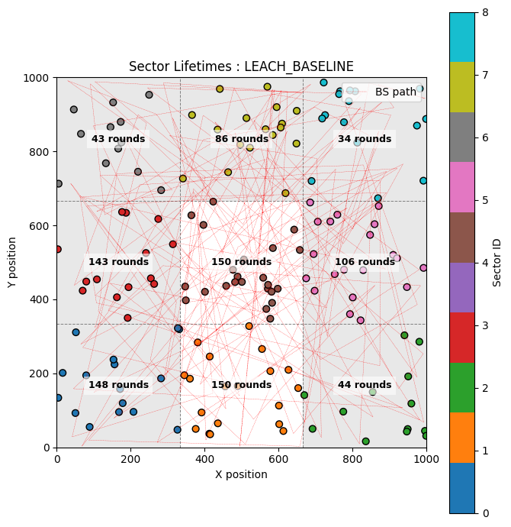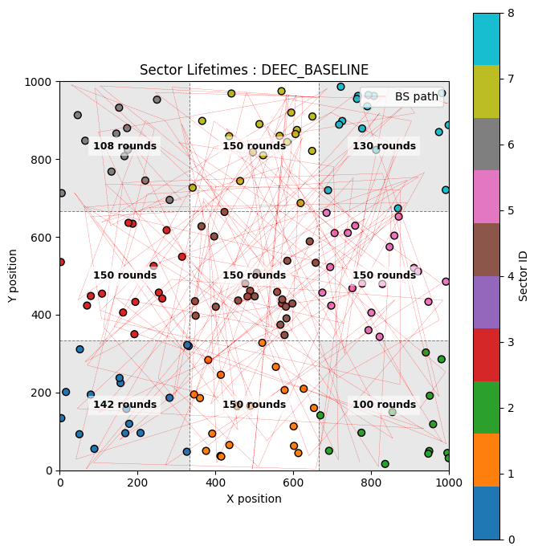

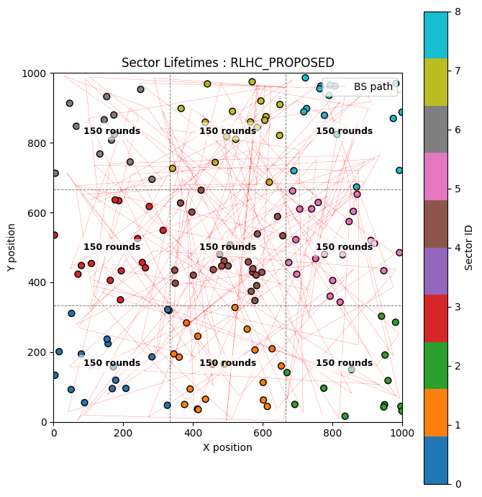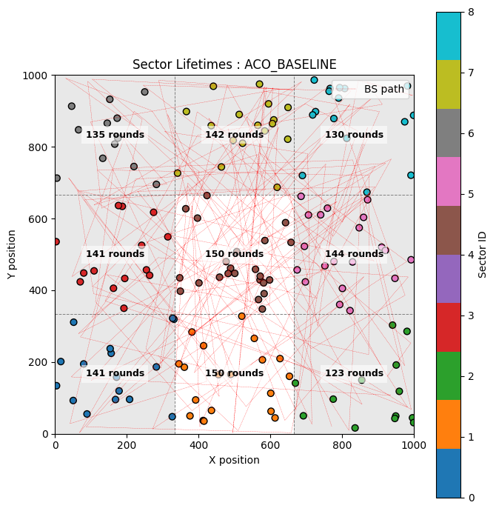

***Note: We now disable each layer individually and observe the impact it produces.***

|  |  |  |  |  |  |
| --- | --- | --- | --- | --- | --- |
| **CONFIG: RLHC** | **Layer 1: ✅** | **Layer 2: ✅** | **Layer 3: ✅** | **Layer 4: ✅** | **Layer 5:** ❌ |

**Table 3:** Lifetime vs Rounds

|  |  |  |  |  |  |
| --- | --- | --- | --- | --- | --- |
| **Method** | **1st Node Death (rounds)** | **50% Nodes Death (rounds)** | **75% Nodes Death (round)** | **100% Node Death (round)** | **%PDR** |
| LEACH | 7 | 33 | 207 | 244 | 92.45 |
| DEEC | 13 | 93 | 205 | 241 | 98.08 |
| FCM | 7 | 61 | 554 | 598 | 93.42 |
| PSO-GA | 1 | 77 | 199 | 262 | 96.74 |
| ACO | 8 | 96 | 157 | 169 | 93.05 |
| RLHC (proposed) | 7 | 114 | 508 | 548 | 96.97 |

**Table 2:** Energy consumed and Throughput vs Rounds

|  |  |  |
| --- | --- | --- |
| **Methods** | **Energy Consumed (J)** | **Throughput (kbps)** |
| LEACH | 291.94 | 7 |
| DEEC | 284.12 | 14 |
| FCM | 277.73 | 10 |
| PSO-GA | 282.32 | 13 |
| ACO | 296.28 | 13 |
| RLHC (proposed) | 268.2 | 15 |

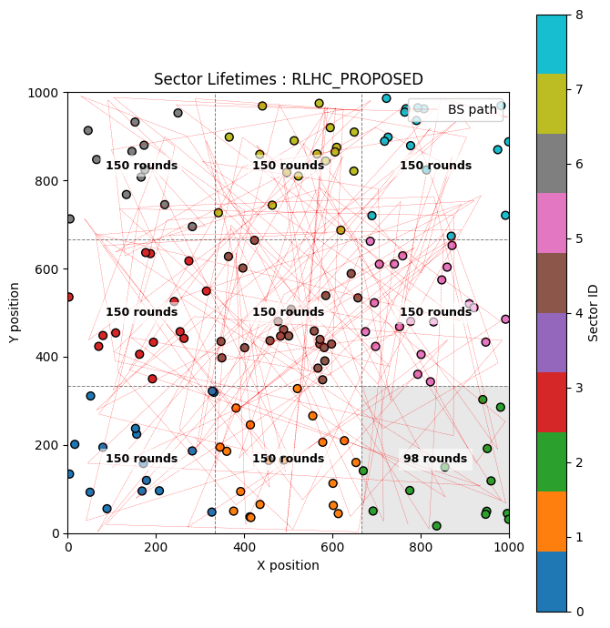

|  |  |  |  |  |  |
| --- | --- | --- | --- | --- | --- |
| **CONFIG: RLHC** | **Layer 1: ✅** | **Layer 2: ✅** | **Layer 3: ✅** | **Layer 4:** ❌ | **Layer 5:** ❌ |

**Table 3:** Lifetime vs Rounds

|  |  |  |  |  |  |
| --- | --- | --- | --- | --- | --- |
| **Method** | **1st Node Death (rounds)** | **50% Nodes Death (rounds)** | **75% Nodes Death (round)** | **100% Node Death (round)** | **%PDR** |
| LEACH | 7 | 33 | 207 | 244 | 92.45 |
| DEEC | 13 | 93 | 205 | 241 | 98.08 |
| FCM | 7 | 61 | 554 | 598 | 93.42 |
| PSO-GA | 1 | 77 | 199 | 262 | 96.74 |
| ACO | 8 | 96 | 157 | 169 | 93.05 |
| RLHC (proposed) | 5 | 106 | 484 | 512 | 95.84 |

**Table 2:** Energy consumed and Throughput vs Rounds

|  |  |  |
| --- | --- | --- |
| **Methods** | **Energy Consumed (J)** | **Throughput (kbps)** |
| LEACH | 291.94 | 7 |
| DEEC | 284.12 | 14 |
| FCM | 277.73 | 10 |
| PSO-GA | 282.32 | 13 |
| ACO | 296.28 | 13 |
| RLHC (proposed) | 280.34 | 15 |

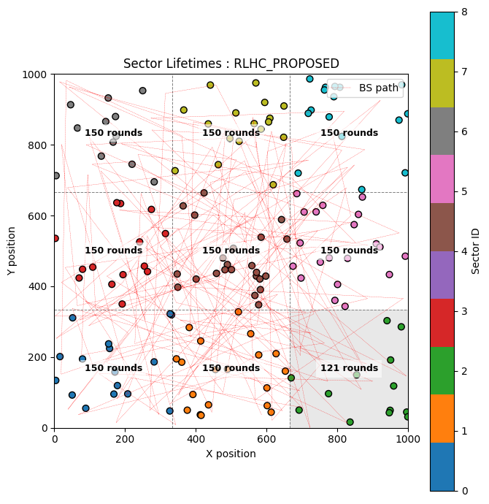

|  |  |  |  |  |  |
| --- | --- | --- | --- | --- | --- |
| **CONFIG: RLHC** | **Layer 1: ✅** | **Layer 2: ✅** | **Layer 3:** ❌ | **Layer 4:** ❌ | **Layer 5:** ❌ |

**Table 3:** Lifetime vs Rounds

|  |  |  |  |  |  |
| --- | --- | --- | --- | --- | --- |
| **Method** | **1st Node Death (rounds)** | **50% Nodes Death (rounds)** | **75% Nodes Death (round)** | **100% Node Death (round)** | **%PDR** |
| LEACH | 7 | 33 | 207 | 244 | 92.45 |
| DEEC | 13 | 93 | 205 | 241 | 98.08 |
| FCM | 7 | 61 | 554 | 598 | 93.42 |
| PSO-GA | 1 | 77 | 199 | 262 | 96.74 |
| ACO | 8 | 96 | 157 | 169 | 93.05 |
| RLHC (proposed) | 5 | 113 | 120 | 129 | 93.37 |

**Table 2:** Energy consumed and Throughput vs Rounds

|  |  |  |
| --- | --- | --- |
| **Methods** | **Energy Consumed (J)** | **Throughput (kbps)** |
| LEACH | 291.94 | 7 |
| DEEC | 284.12 | 14 |
| FCM | 277.73 | 10 |
| PSO-GA | 282.32 | 13 |
| ACO | 296.28 | 13 |
| RLHC (proposed) | 299.9 | 9 |

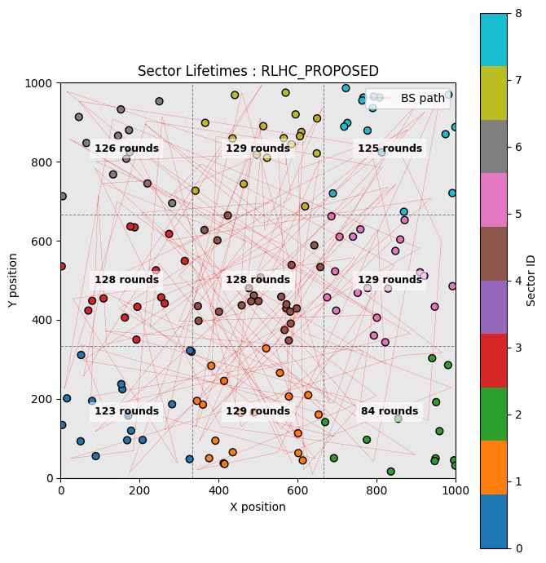

1. **Discussion & Summary of Key Findings**
2. Key Findings
   1. RLHC outperforms LEACH, DEEC, FCM, PSO-GA and ACO in all scenarios.
   2. It provides longer network lifetime and higher packet delivery ratio (PDR).
3. Novelty of RLHC
   1. Integrates reinforcement learning to globally optimize clustering and routing.
   2. Can activate/deactivate layers based on BS mobility (self-optimization).
   3. Uses hybrid clustering with multi-hop routing for dynamic cluster and path adjustment.
   4. Overcomes limitations of static protocols under changing dynamic environment.
4. Real-world Implications
   1. Suitable for IoT with static, periodic or random BS mobility.
   2. Good fit for dynamic and unpredictable environment such as underground mines.
   3. Higher energy efficiency, longer network lifetime and lower maintenance cost.
   4. High PDR, reliable communication for critical applications (e.g., monitoring, smart cities).
5. Future Work
   1. Further tuning and improving the RL model.
   2. Studying more complex BS mobility patterns.
   3. Validating on large-scale networks and diverse environments.
   4. Testing under varied traffic patterns, node densities, and heterogeneous sensor types.

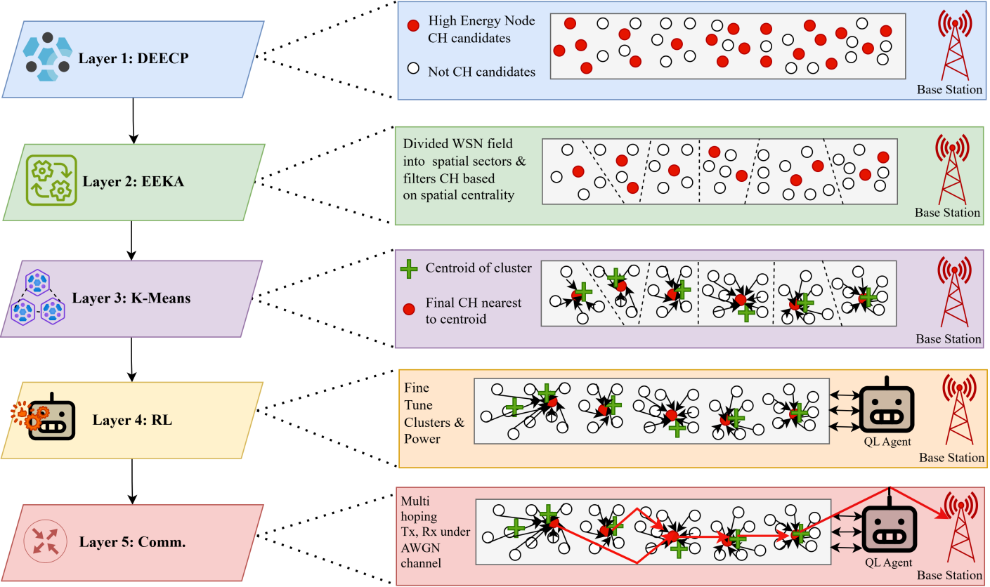

*Fig 1: RLHC Architecture*

-------------------------END-------------------